**Heroes of Pymoli Data Analysis**

The purchasing analysis shows us the total revenue generated was $2,379.77 with the average price at $3.05. Though the total number of game purchases is 780, the number of unique items purchased is only 179. This means repeat purchases of some game titles did occur.

Based on the gender demographics, males (652 total) make up the majority of the players at 83.59% compared to the smaller, but notable proportion of female players (113 total) at 14.49%. However, as a whole, females averaged $0.18 higher purchase price at $3.20 vs males at $3.02.

Our peak age demographic falls between 20-24 (46.79%) with secondary groups falling between 15-19 year olds (17.44%) and 25-29 (12.95%).

Average purchase price per age group ranges between $2.90 - $3.60, with the highest average purchase price belonging to the 35-39 year old players. The majority age demographic of 20-24 year olds averaged $3.05 on their game purchases.

The overall top spender is screen name “Lisosia93” at $18.96 and averaged $3.79 per purchase. The next two top spenders are as follows:

Screen name “Idastidru52” with total purchase value at $15.45 (average $3.86)

Screen name “Chamjask73” with total purchase value at $13.83 (average $4.61)

The 4th and 5th top spenders were not too far behind at $13.62 and $13.10 in total purchases respectively.

The overall most popular game based on the total purchase count is “Oathbreaker, Last Hope of the Breaking Storm”. Details of the top 5 games based on purchase count are follows: (see Figure 1)

Figure 1: **Most Popular Items**

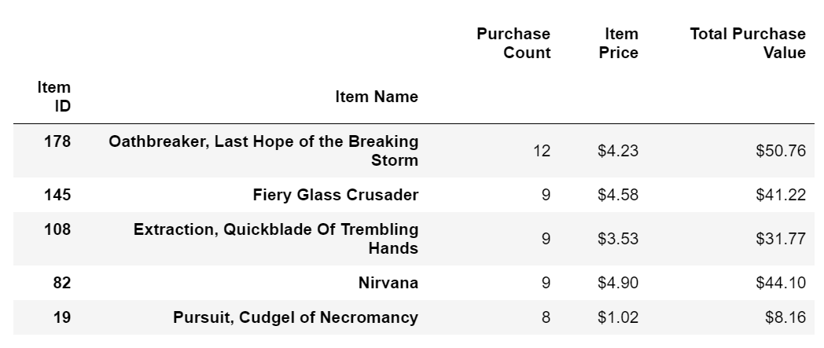

“Oathbreaker, Last Hope of the Breaking Storm” is also the top most profitable game based on the total purchase value. The #2, #3, #4 profitable games differ from the popular games. “Nirvana” is our 2nd most profitable game, however it ranked #4 in popularity. “Fiery Glass Crusade” is the #3 most profitable, but is #2 in popularity. (See Figure 2)

Figure 2: **Most Profitable Items**

